Question 3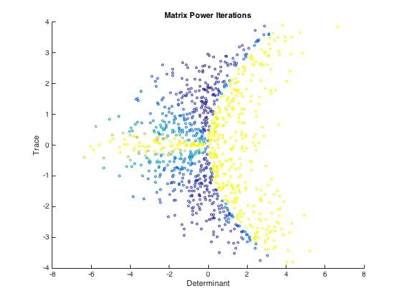

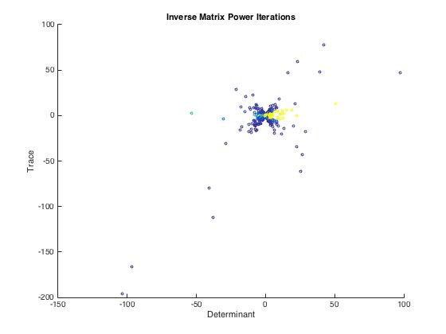

Power Method Interpretations

In the written component for this part, interpret your graphs from part (c). Especially explain why the graphs look the way they do.

The graph for the original matrix is a rotated parabola. The parabola comes from the equation for the determinant-trace plane:

$T = 2 ±\sqrt{D}$

where T is the trace of the matrix, and D is the determinant of the matrix. This is taken from the formula to find eigenvalues:

$λ =\frac{(T ±\sqrt{T^{2}-4D} )}{2}$

When the expression $T^{2}-4D = 0$, the eigenvalues are repeated. When the expression $T^{2}-4D < 0$, there are two complex eigenvalues, and when the expression $T^{2}-4D > 0$, there are two distinct, real eigenvalues.

Thus, in our graphs, there are a set of values that are greater than the parabola, and a set of values that are less than the parabola. These values are determined by the determinant and the trace and the relationship between the two. The color indicates the number of iterations required to reach the solution for that matrix. Consistent with what was said previously, the lighter colors indicate that the iterations reached its max, and the darker colors indicate a fewer number of iterations. The lighter colors are located in areas greater than the parabola, and darker colors are located in areas less than the parabola.

For the inverse matrix, the graph looked like a hyperbola. It is most likely just the parabola from the normal matrix mirrored. This makes sense because the matrix is inverted, so the trace of the inverted matrix is equal to the trace of the original matrix divided by the determinant of the original matrix.